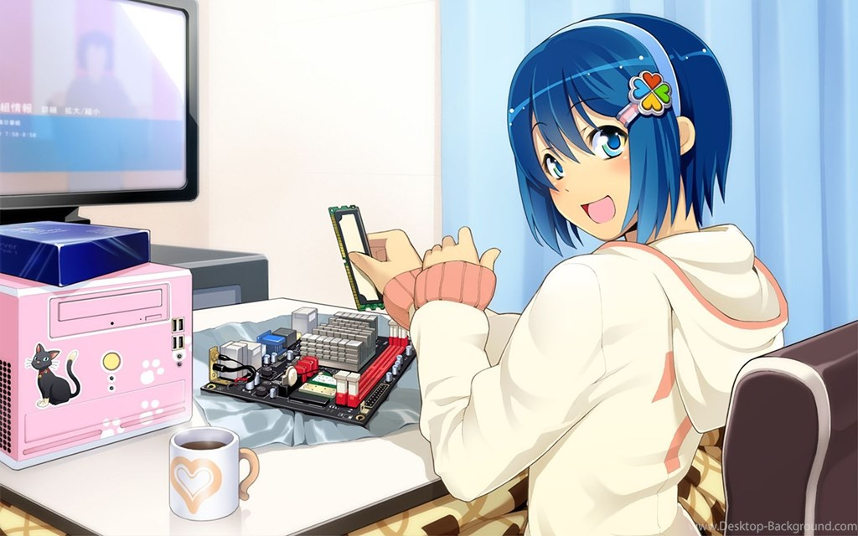

This is the story of the game. There was a person (choose boy or girl?) who was living at home but very unhappy. They are in fact depressed. The kid goes out one day and falls into an adventure. On this adventure she discovers the world around her, discovered other people have the same issues as her, discovers magic and finally discovers herself.

**Cupantae.ie Games**

**Carraroe, Co Galway**

**087 2716947**

**donalod@gmail.com**

June 2019

**Game Two**

**Technical Design Document**

Contents

Section 1 - Game Overview 3

1.1. Game Title: 3

1.2. Game Genre: 3

1.3. Game Perspective: 3

1.4. Game Mode(s): 3

1.5. Target Audience: 3

1.6. Core Idea: 3

1.7. Goal: 3

Section 2 - Game background 3

2.1. Background Story: 3

2.2. Characters Starting Their Story 3

Section 3 - Gameplay 4

3.1. Objectives 4

3.2. Game Logic 4

3.3. Mechanics 4

3.3.1. Rules 4

3.3.2. In-game Help and Info: 4

# List of Features Captured from the Game Design Document

## List of features based on the GDD

* Third person
* Game world, including
  + 3D objects
  + Characters
  + Weapons
  + Buildings with walls, corridors, doors, stairs, rooms
* Windows platform deployed
* Background story
* Opening scene
* Different levels:
  + Varying difficulty
  + Varying challenge
  + New levels introduce new weapons
* Multiplayer
* Different destructible weapons
* Audio and sound effects
* Variety of enemies (two types of zombies)
* Realistic AI of zombies
* Scoring system
* Comprehensive/informative HUD
* Menus
* Lighting effects
* Interactive objects
* Staff ID cards
* Vending machines

## 

# Choice of Game Engine

The game will be created using the Unity3D game engine. There are many other game engines that we could have gone for, and these include:

* **Unreal Engine** – The undisputed heavy weight of game engines. If you want literally anything done in a game – Unreal can do it. This Rolls Royce of games engines is even free to download, free to make a game in. But there is one stumbling block. The engine is in C++. We, rather I Donal, do not know C++. I have a fair idea about a lot of C++ but when you are beginning to chase out bugs from the project and your eyes red from staring at the screen, you do not want to be feeling your way around the engine in the dark. In this regard, we know Unity better from an interface and C# point of view.
* **GameMaker Studio** – Sells itself as a game engine that does not require programming, of course then you proceed to learn its programming language to be able to use the game to any degree. Great engine with that said, and brilliant for 2D.
* **Godot** – This is a free (MIT Licence) game engine. There is a fair amount of documentation out on the net about it, as engines go it is reatively young.
* **CryEngine** – There is a fair amount to learn in this engine. It is simply not as popular amoungst hobbiests, which is what we are really at the moment (none of us are doing this game as their full time job). CryEngine gives beautiful graphics, amazing characters and environments – much like Unreal or Unity.
* **Amazon Lumberyard** – I heard about this game engine a few years ago – 1 or 2 years ago – but I have not heard much since. Says more about me than it does about the engine, or does it? Basically game libraries on AWS… why bother really when we are not looking for massive scaling.
* **RPG Maker** – This is a brilliant choice for someone who decides to make a game. People have made themselves rich from RPG Maker games. But it simply not we are looking to do – an RPG I mean (we’ll take the money).

The reason all these other game engines are covered here is to show any questioning reader that we have thought of various other game engines. There are other programming languages and engines out there of course, many more that are not on the list, but as beginners that will be needing a lot of help, that are looking for a quick development time and turn around for the project we have decided that Unity is the correct choice for us.

When this TDD was being written Unity was up to version 2019.1. When we do decide to begin coding we will freeze the version of Unity and just continue on with that version. Also, Unity updates their software a lot, a few times a year with smaller updates and major updates every few years. These updates can, I have learnt from experience, have drastic results if you load your older project into a newer version of Unity. Also we do not want to go with the latest version from a bug point of view. Unity is pretty huge and does have a few bugs in it, and with new version coming out all the time, there are usually some small bugs in the system.

Nevertheless, Unity is a great choice for us.

# Schedule

|  |  |  |  |  |  |  |  |  |  |  |  |  |  |  |
| --- | --- | --- | --- | --- | --- | --- | --- | --- | --- | --- | --- | --- | --- | --- |
| Task | Week 1 | Week 2 | Week 3 | Week 4 | Week 5 | Week 6 | Week 7 | Week 8 | Week 9 | Week 10 | Week 11 | Week 12 | Week 13 | Week 14 |
|  | 17-Jun-19 | 24-Jun-19 | 01-Jul-19 | 08-Jul-19 | 15-Jul-19 | 22-Jul-19 | 29-Jul-19 | 05-Aug-19 | 12-Aug-19 | 19-Aug-19 | 26-Aug-19 | 02-Sep-19 | 09-Sep-19 | 16-Sep-19 |
| Game Design Document Approval |  |  |  |  |  |  |  |  |  |  |  |  |  |  |
| Technical Design Document Approval |  |  |  |  |  |  |  |  |  |  |  |  |  |  |
| Create Levels |  |  |  |  |  |  |  |  |  |  |  |  |  |  |
| Create Characters |  |  |  |  |  |  |  |  |  |  |  |  |  |  |
| Create Objectives & Weapons |  |  |  |  |  |  |  |  |  |  |  |  |  |  |
| Create Triggers and Events |  |  |  |  |  |  |  |  |  |  |  |  |  |  |
| Coding |  |  |  |  |  |  |  |  |  |  |  |  |  |  |
| Release For Testing |  |  |  |  |  |  |  |  |  |  |  |  |  |  |
| Testing |  |  |  |  |  |  |  |  |  |  |  |  |  |  |
| Create Website for journaling and Progress |  |  |  |  |  |  |  |  |  |  |  |  |  |  |
| Create Social Media For Game and Post Progress |  |  |  |  |  |  |  |  |  |  |  |  |  |  |
| Create Walkthrough |  |  |  |  |  |  |  |  |  |  |  |  |  |  |
| Play final version of the game |  |  |  |  |  |  |  |  |  |  |  |  |  |  |
| Put Game on Itch |  |  |  |  |  |  |  |  |  |  |  |  |  |  |
| Put Game on Stream |  |  |  |  |  |  |  |  |  |  |  |  |  |  |

## Objectives

Bullet point below the gameplay objectives.

## Game Logic

* Will object have “life” like hit points? Can items be used up or “break”. If I have a gun if it shoots too many bullets it will break? Like in Minecraft, will an axe break if i use it too many times?
* Player cannot lift things that are too heavy – will items have weight?
* Can player run faster than character in real life?
* Enemies have basically same rules to follow as player.

## Mechanics

### Rules

* Characters cannot jump out of windows.
* If the characters health reaches zero then that character dies and that level needs to be repeated.
* Characters can only use a weapon a certain amount of times?
* Different weapons have a different amount of times that they can be used?
* Characters cannot get through doors without a key?
* The player cannot progress to the next level without completing the previous leve?
* Characters cannot run through walls or doors that are closed.
* Player starts with no weapons and collects weapons on the way.
* If the players character is killed by an enemy then the level must be started again.

### In-game Help and Info:

* When the game starts up the player is prompted to do the following actions (to help understand how to play the game):
  + Move around
  + Look around
  + Punch
  + Interact with objects
  + Look for key card in the room
  + Interact with the key card – pick it up and use it to open the door